Proudly present their

Y2K Gala 2022
(under A.S.A Law and A.S.A Technical Rules)

AT FENTON MANOR, STOKE ON TRENT.
Saturday 9th & Sunday 10th April 2022
Licensed at Level 3
(3WM)

This event is FIRST COME FIRST SERVED BASIS

To avoid disappointment please submit your entry early

In a 6-Lane, 25m Pool, Anti-Wave Lane Ropes,

Full Display Omega Electronic Timing

Awards to first three places

9yr, 10yr, 11yr, 12yr, 13yr, 14yr, 15/OV

Age as at: 10/04/2022
Entry: £6.50 per event
Entries Closing Date: 19/03/2022

email: openmeetsecretary@cosacss.co.uk

ALL ENTRY FORMS AND DETAILS CAN BE DOWNLOADED FROM THE CLUB’S WEBSITE – www.cosacss.co.uk
PROGRAMME OF EVENTS

ALL EVENTS 9 – 15/Over in single age groups

SESSION 1: (WARM UP to be advised) SATURDAY 9th APRIL 2022

Event No | Sex | Event | Length
101 | Girls | Freestyle | 200m
102 | Boys | Backstroke | 200m
103 | Girls | Butterfly | 50m
104 | Boys | Freestyle | 50m
105 | Girls | Breaststroke | 100m
106 | Boys | Butterfly | 100m
107 | Girls | Backstroke | 100m

SESSION 2: (WARM UP To be advised) SATURDAY 9th APRIL 2022

Event No | Sex | Event | Length
201 | Boys | Freestyle | 200m
202 | Girls | Breaststroke | 200m
203 | Boys | Backstroke | 50m
204 | Girls | Backstroke | 50m
205 | Boys | Breaststroke | 100m
206 | Girls | Butterfly | 100m
207 | Boys | Freestyle | 100m

SESSION 3: (WARM UP to be advised) SUNDAY 10th APRIL 2022

Event No | Sex | Event | Length
301 | Girls | Ind Medley | 200m
302 | Boys | Breaststroke | 200m
303 | Girls | Breaststroke | 50m
304 | Boys | Butterfly | 50m
305 | Girls | Freestyle | 100m
306 | Boys | Ind Medley | 100m
307 | Girls | Butterfly | 200m

SESSION 4: (WARM UP To be advised) SUNDAY 10th APRIL 2022

Event No | Sex | Event | Length
401 | Boys | Ind Medley | 200m
402 | Girls | Backstroke | 200m
403 | Boys | Breaststroke | 50m
404 | Girls | Freestyle | 50m
405 | Boys | Backstroke | 100m
406 | Girls | Ind Medley | 100m
407 | Boys | Butterfly | 200m

RULES AND CONDITIONS

- All events are open to members of clubs affiliated to the ASA.

- All entrants must pay the entry fee of £6.50 per event

- Entries will only be accepted below the Upper Limit Times

- In the event that the gala is oversubscribed the club reserve the right to close entries before the closing date

- Ages as at 10/04/2022

- Session Start times will be confirmed on the clubs web site.

- The Morning sessions will start at approximately 9:00am on both days.

- Coaches passes are available in advance of the competition at £5.00 per day..

- WITHDRAWAL PROCEDURE
- In order to keep the Gala running as smoothly as possible we would be obliged if you could advise us of any withdrawals as follows:
- Up to 6 pm on preceding evening please E Mail at openmeetsecretary@cosacss.co.uk
- Text to 07880 332922 Stating Name, Club, Event.

- Awards will be made to the first three places in each event and in each age group as defined below.
9 yr, 10yr, 11yr, 12yr, 13yr, 14yr, 15/OV.
Top Girl and Top Boy trophies awarded.

- All events are Heat Declared Winner.

- The competition will be run using Over The Top Starts with the exception of backstroke.

- Club Entries to be accompanied by one bank transfer

- We would appreciate that all clubs who have more than 5 swimmers entered provide at least 1 qualified official. Please email your details to nik_cartlidge@yahoo.co.uk

- Any matter not directly referred to in these rules & conditions will be dealt with at the discretion of the promoter Greg Clarke (The City of Stoke on Trent S.C. (COSACSS)).

- Any complaints about these conditions should be directed to the promoter Greg Clarke.

- We reserve the right to allow COSACSS swimmers who do not meet the entry requirements to swim for a time only.

Additional Covid-19 requirements.

- Meet Promoter: Mr. Greg Clarke

- Meet Covid Lead: Mrs. Diane Leathem

- Covid-19 and Social Distancing

- A Covid Lead has been appointed for this competition, details as above, and there will be a team of Covid Liaison Officers present at the competition, in order to ensure compliance with social distancing guidelines in place at the time of the competition.

- This competition is being planned on the assumption that some social distancing measures will remain in place at the time of the competition for indoor activities deemed to be high risk such as swimming competitions.

- If it becomes clear before the event that any such restrictions are removed, relaxed or tightened, then these conditions may alter between the time of issue and the event taking place. Any such revisions will be published on the clubs website.

- We reserve the right to cancel this competition if it is unable to proceed due to changes in government legislation and/or guidance.

- A Covid-19 risk assessment, which will be an evolving document as the situation changes, will be agreed with the pool operator.

- We request that everyone attending the gala takes a lateral flow test on the evening before their attendance. to the Covid Lead.

- It is recommended that due to the nature of current circumstances, nobody commits to nonrefundable travel or accommodation. The promoter will not be responsible for any losses, regardless of circumstances or cause.

- By entering this competition, or the purchase of a coaches/team managers/chaperones pass, competitors and their supporters agree that they will follow the instructions of the Covid-19 team at all times. Failure to do so may result in the removal from the premises and competition.

- It is a condition of attending this meet, that anyone showing symptoms of Covid-19 or signs of illness do not attend the competition. Anyone showing symptoms/signs will be escorted to a separate area to be isolated from others.

Individual Entry Form

Full Name: ……………………………………………………………
Telephone: ………………
e-mail: ……………………………..
Club: ……………………………………………………………
Date of Birth: …….../…..…./…..…..
ASA Reg. No. ……………………………..
Gender: Male/Female

Event | Submitted Time | Event | Submitted Time
50m Free |  | 100m Breast
100m Free |  | 200m Breast
200m Free |  | 50m Fly
50m Back |  | 100m Fly
100m Back |  | 200m Fly
200m Back |  | 100m I.M
50m Breast |  | 200m I.M

Total Number of Events entered: ………….

Total Paid (£6.50 per event): ………….

See payment options on CLUB Entry form – thank you.

Final date for entries: 19/03/2022

PleaseEmail entries to: openmeetsecretary@cosacss.co.uk

Please note accepted entries will be posted on the clubs web site www.cosacss.co.uk approximately 2 weeks prior to the meet.

Club Entry Form

Please complete the relevant sections below and send it along with your payment to The City of Stoke on Trent S.C. (See Payment details below)

Club entry should be via the Sportsystems entry file available by email from openmeetsecretary@cosacss.co.uk

For individual entries please check your swimmers entry forms and ensure that all relevant sections are completed properly, especially DOB and ASA Reg.

Club Name: …………………………………………

Contact Name: …………………………………………

Email address: …………………………………………………

Telephone: …………………………………………

Number of entries at £6.50 £ …………

Coaches Passes Required for Saturday ………. at £5.00 £ …………

Coaches Passes Required for Sunday ………. at £5.00 £ …………

Total Amount Payable £ …………

Final date for entries: 19/03/2022

email Electronic Entries to openmeetsecretary@cosacss.co.uk

Please note accepted entries will be posted on the clubs web site www.cosacss.co.uk approximately 2 weeks prior to the meet.

Payment by Bank Transfer to: Sort code 08-92-99 Account No. 65221918

City of Stoke on Trent SMG Club COSACSS

Enquiries by email: openmeetsecretary@cosacss.co.uk

No times faster than ULT will be accepted

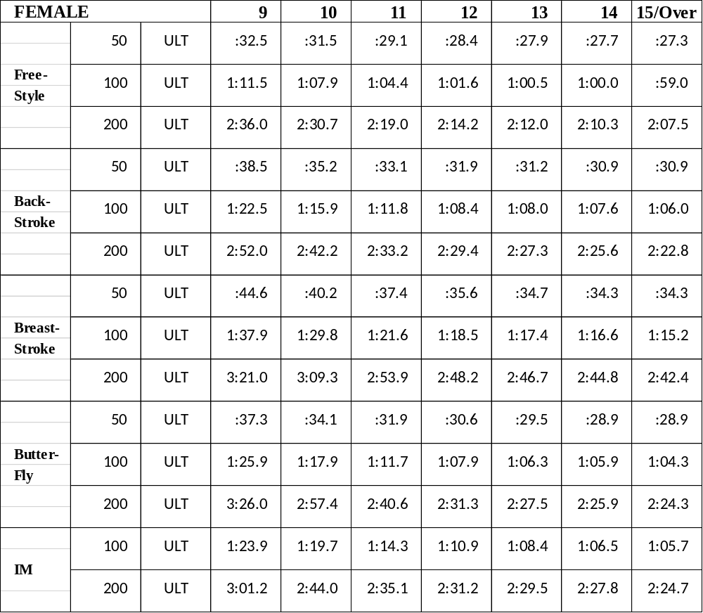

No times faster than ULT will be accepted

MALE |  |  | 9 | 10 | 11 | 12 | 13 | 14 | 15/Over
 | 50 | ULT | 32.0 | 31.3 | 29.0 | 27.5 | 26.1 | 25.2 | 24.3
Free- | 100 | ULT | 1:10.5 | 1:07.5 | 1:04.0 | 59.9 | 56.9 | 54.5 | 52.9
Style
 | 200 | ULT | 2:34.9 | 2:20.5 | 2:18.5 | 2:11.8 | 2:04.1 | 1:59.6 | 1:56.6
 | 50 | ULT | 38.0 | 34.2 | 32.1 | 30.5 | 29.2 | 28.5 | 27.9
Back- | 100 | ULT | 1:20.5 | 1:14.7 | 1:09.6 | 1:05.8 | 1:00.6 | 1:01.4 | 59.9
Stroke
 | 200 | ULT | 2:50.1 | 2:40.2 | 2:29.2 | 2:20.5 | 2:18.5 | 2:14.0 | 2:11.8
 | 50 | ULT | 44.5 | 40.3 | 37.2 | 34.3 | 32.4 | 30.9 | 30.5
Breast- | 100 | ULT | 1:40.0 | 1:28.4 | 1:21.3 | 1:14.3 | 1:12.5 | 1:09.5 | 1:07.5
Stroke
 | 200 | ULT | 3:12.6 | 3:02.1 | 2:47.7 | 2:42.7 | 2:36.3 | 2:32.2 | 2:28.20
 | 50 | ULT | 38.0 | 34.0 | 31.4 | 29.8 | 28.0 | 27.2 | 26.0
Butter- | 100 | ULT | 1:26.2 | 1:17.3 | 1:12.0 | 1:06.2 | 1:02.1 | 59.3 | 57.7
Fly
 | 200 | ULT | 3:26.0 | 2:56.3 | 2:40.1 | 2:28.3 | 2:18.6 | 2:13.8 | 2:11.0
 | 100 | ULT | 1:20.0 | 1:19.0 | 1:14.3 | 1:09.0 | 1:05.0 | 1:01.8 | 1:00.8
IM
IM | 200 | ULT | 3:01.5 | 2:46.3 | 2:36.0 | 2:26.6 | 2:18.3 | 2:15.2 | 2:11.7

POOLSIDE PASSES – APPLICATION FORM

CLUB:

DAY | DATE | NUMBER | COST
Day 1 | Saturday 9th April |  | £5.00
Day 2 | Sunday 10th April |  | £5.00
TOTALS |  |  | x £5.00

Please print below the name and telephone number of the person applying in case of query:

NAME: ………………………………… Telephone No. ………………

Please print below the names of ALL the coaches and helpers who are likely to use them.
All those you name MUST be registered on the ASA Coaches & Helpers Database (Child Protection)

Forename | Surname | DBS Number

PASSES CANNOT BE PURCHASED ON THE DAY OF COMPETITION

